Koneru Lakshmaiah Education Foundation
(Deemed to be University)
FRESHMAN ENGINEERING DEPARTMENT

A Project Based Lab Report On

Automated Household Inventory & Intelligent Consumption Analytics System (HI-CAS)

SUBMITTED BY:
2500030525 | BEERAM L V SAHITHI
2500030705 | POTTI TIRUMALA LAXMI SAI
2500030808 | KARTHIK MAHADEO TEKADE
25000300565 | BODDU VEERENDRA SAI

UNDER THE ESTEEMED GUIDANCE OF Dr. V. PREMALATHA
ASSISTANT PROFESSOR



KL UNIVERSITY
Green fields, Vaddeswaram – 522 502 Guntur Dt., AP, India.

DEPARTMENT OF BASIC ENGINEERING SCIENCES-1



CERTIFICATE

This is to certify that the project based laboratory report entitled “Automated Household Inventory & Intelligent Consumption Analytics System (HI-CAS)” submitted by BEERAM L V SAHITHI, BODDU VEERENDRA SAI, POTTI TIRUMALA LAXMI SAI, KARTHIK MAHADEO TEKADE bearing Regd. No. 2500030525, 2500030565, 2500030705, 2500030808 to the Department of COMPUTER SCIENCE ENGINEERING , KL University in partial fulfillment of the requirements for the completion of a project based Laboratory in “PYTHON PROGRAMMING (25SC2007)” course in I B Tech II Semester, is a Bonafide record of the work carried out by them under my supervision during the academic year 2025 – 2026.

PROJECT SUPERVISOR HEAD OF THE DEPARTMENT

Dr. V. PREMALATHA Dr. D. HARITHA

ACKNOWLEDGEMENTS

It is great pleasure for me to express my gratitude to our honorable President. Sri. Koneru Satyanarayana, for giving the opportunity and platform with facilities in accomplishing the project-based laboratory report.
We express sincere gratitude to our Director Dr. A. Jagdeesh for his administration towards our academic growth. We express sincere gratitude to our Principal Dr. V. Krishna Reddy for his administration towards our academic growth.
We express sincere gratitude to our HOD-BES-1 Dr. D. Haritha for her leadership and constant motivation provided for the successful completion of our academic semester. We record it as my privilege to deeply thank you for providing us with the efficient faculty and facilities to make our ideas into reality.
We express our sincere thanks to our project supervisor Dr V. Premalatha for his novel association of ideas, encouragement, appreciation, and intellectual zeal which motivated us to venture this project successfully.
Finally, We are pleased to acknowledge our indebtedness to all those who devoted themselves directly or indirectly to making this project a success.

2500030525 | BEERAM L V SAHITHI
2500030565 | BODDU VEERENDRA SAI
2500030705 | POTTI TIRUMALA LAXMI SAI
2500030808 | KARTHIK MAHADEO TEKADE

ABSTRACT
Automated Household Inventory & Intelligent Consumption Analytics System (HI-CAS) is a Python-based application designed to efficiently manage and monitor household inventory while analyzing consumption patterns. The system allows users to track items such as groceries and daily essentials by adding, updating, deleting, and viewing inventory records. It integrates important Python programming concepts including file handling, data structures, object-oriented programming, and modular design to create an effective inventory management solution. The application also provides features such as low-stock alerts, summary reports, and basic consumption analysis to help users make better purchasing decisions. The system supports multiple file formats like text, CSV, and JSON for storing and processing data, making it a practical and structured application for learning Python while solving real-world household management problems.
Key Words: Household Inventory Management, Python Programming, Consumption Analytics, Data Structures, File Handling, Object-Oriented Programming, JSON, Data Analysis.

INDEX

S.NO | TITLE | PAGE NO
1 | Introduction | 6
2 | Aim of the Project | 7
2.1 | Advantages & Disadvantages | 8
2.2 | Future Implementation | 8
3 | Software & Hardware Details | 9
4 | Data Flow Diagram | 10
5 | Algorithm for each module | 11-13
6 | Implementation | 14-17
7 | Integration and System Testing | 18-22
8 | Conclusion | 23

INTRODUCTION
In today’s modern lifestyle, managing household items efficiently has become increasingly important. Families regularly purchase groceries, daily essentials, and other household supplies, and without proper tracking it becomes difficult to monitor stock levels and consumption. This can lead to over-purchasing, wastage, or running out of essential items at inconvenient times. To solve this problem, the Automated Household Inventory & Intelligent Consumption Analytics System (HI-CAS) is developed as a simple and efficient solution for managing household inventory. The system helps users keep track of items in a structured manner and improves the overall management of household supplies.
The HI-CAS system is a Python-based application that allows users to add, update, view, and delete inventory records. The project uses important Python concepts such as data structures, object-oriented programming, and file handling to store and manage data effectively. Inventory data can be saved using formats such as JSON or CSV, ensuring that the information is stored permanently. In addition, libraries like Pandas and Matplotlib can be used to display data in tabular form and visualize consumption patterns through graphs, helping users analyze usage trends and make better purchasing decisions.

AIM

The aim of the Automated Household Inventory & Intelligent Consumption Analytics System (HI-CAS) is to develop a Python-based application that helps users efficiently manage household inventory and analyze consumption patterns. The system is designed to store, update, and monitor household items such as groceries and daily essentials while providing useful insights like low-stock alerts and consumption trends to improve household resource management and decision-making.

ADVANTAGES

- Helps in efficient management of household items and inventory.
- Reduces wastage and prevents running out of essential items.
- Provides basic analysis of consumption patterns.
- Stores data in structured formats like JSON or CSV for easy access.

DISADVANTAGES

- Requires manual input of inventory data.
- Limited to basic analytics and features.
- Requires Python environment to run the system.
- Does not automatically update inventory without user interaction.

FUTURE IMPLEMENTATION

- Development of a mobile or web-based version of the system.
- Integration of barcode or QR code scanning for automatic item entry.
- Addition of advanced analytics using machine learning.
- Cloud-based storage for better data backup and accessibility.

SYSTEM REQUIREMENTS

SOFTWARE REQUIREMENTS:
Operating System: Windows / Linux / macOS
Programming Language: Python (Version 3.x)
Development Environment: Visual Studio Code / PyCharm
Python Libraries: Pandas, Matplotlib, JSON, CSV
Python Interpreter: Python IDLE or Command Prompt.

HARDWARE REQUIREMENTS:
• RAM: 8 GB
• Processor: Intel Core i5 or equivalent
• Storage: Minimum 1 GB free disk space
• System: Laptop or Desktop Computer

DATA FLOW DIAGRAM

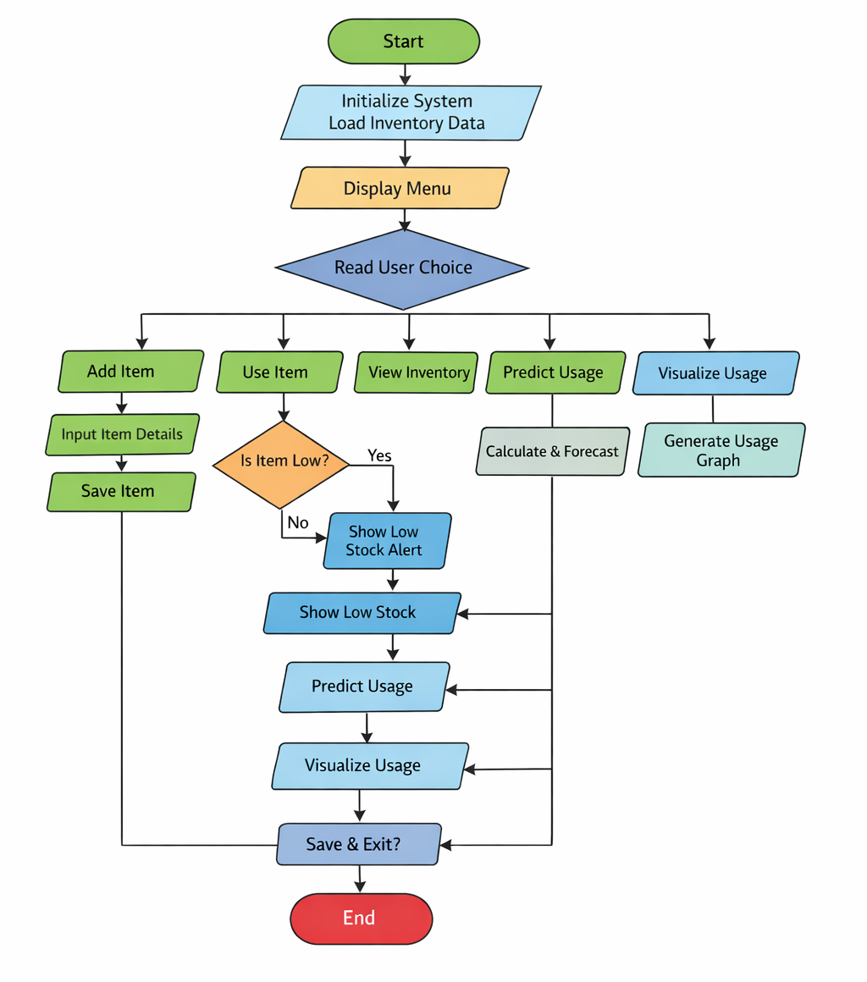

ALGORITHAM
Step 1: Start
Step 2: Initialize System
Step 2.1: Import required libraries (JSON, NumPy, Pandas, Matplotlib, Datetime)
Step 2.2: Define file name for storing inventory data (inventory.json)
Step 2.3: Create object of InventoryManager
Step 2.4: Load existing inventory data from file using load_inventory()
Step 2.5: Store loaded items in dictionary structure
Step 3: Display Menu
Step 3.1: Show options to user:
1. Add Item
2. Use Item
3. View Inventory
4. Predict Usage
5. Visualize Usage
6. Save & Exit
Step 4: Read User Choice
Step 4.1: Accept input from user
Step 4.2: Store choice in variable
Step 5: Decision Making Based on Choice
Step 5.1: If Choice = 1 (Add Item)
Step 5.1.1: Read item details from user
- Item Name
- Quantity
- Threshold Value
Step 5.1.2: Create object of SmartItem
Step 5.1.3: Store item in inventory dictionary
Step 5.1.4: Display success message
Step 5.2: If Choice = 2 (Use Item)
Step 5.2.1: Read item name
Step 5.2.2: Check if item exists in inventory
Step 5.2.3: If exists
• Read used quantity
• Reduce item quantity
• Record usage history with date
• Check if item quantity ≤ threshold
• If yes → Display low stock alert
Step 5.2.4: Else → Display “Item Not Found”
Step 5.3: If Choice = 3 (View Inventory)
Step 5.3.1: Check if inventory is empty
• If empty → Display “Inventory Empty”
Step 5.3.2: Else
• Traverse inventory dictionary
• Display item name, quantity, and threshold
Step 5.4: If Choice = 4 (Predict Usage)
Step 5.4.1: Read item name
Step 5.4.2: Check if item exists
Step 5.4.3: If exists
• Extract usage history
• Calculate average usage using NumPy
• Estimate remaining days based on current quantity
• Display prediction results
Step 5.4.4: Else → Display “Item Not Found”
Step 5.5: If Choice = 5 (Visualize Usage)
Step 5.5.1: Read item name
Step 5.5.2: Check if item exists
Step 5.5.3: If exists
• Convert usage history into Pandas DataFrame
• Convert dates into datetime format
• Generate usage trend graph using Matplotlib
• Display graph
Step 5.5.4: Else → Display “Item Not Found”
Step 5.6: If Choice = 6 (Save & Exit)
Step 5.6.1: Save inventory data to JSON file using save_inventory()
Step 5.6.2: Display save confirmation message
Step 5.6.3: Terminate program loop
Step 5.7: Invalid Choice
Step 5.7.1: Display “Invalid Choice” message
Step 6: Repeat Process
• Return to Step 3 until user selects Exit
Step 7: Stop

IMPLEMENTATION

import json
import numpy as np
import pandas as pd
import matplotlib.pyplot as plt
from datetime import datetime

FILE_NAME = "inventory.json"
class Item:
def __init__(self, name, quantity, threshold):
self.name = name
self.quantity = quantity
self.threshold = threshold
self.usage_history = []

def add_usage(self, amount):
self.quantity -= amount
self.usage_history.append({
"date": str(datetime.now().date()),
"used": amount
})

def is_low(self):
return self.quantity <= self.threshold

class SmartItem(Item):
def predict_usage(self):
try:
if len(self.usage_history) == 0:
print("No usage data available.")
return

usage_values = [h["used"] for h in self.usage_history]
avg = np.mean(usage_values)

print(f"Average usage of {self.name}: {avg:.2f}")

if avg > 0:
days_left = self.quantity / avg
print(f"Estimated days left: {int(days_left)} days")
else:
print("Usage too low to predict.")

except Exception as e:
print("Error in prediction:", e)

def visualize_usage(self):
try:
if len(self.usage_history) == 0:
print("No data to visualize.")
return

# Pandas DataFrame
df = pd.DataFrame(self.usage_history)

df["date"] = pd.to_datetime(df["date"])

# Matplotlib visualization
plt.figure()
plt.plot(df["date"], df["used"], marker='o')
plt.title(f"Usage Trend for {self.name}")
plt.xlabel("Date")
plt.ylabel("Usage")
plt.grid()
plt.show()

except Exception as e:
print("Visualization error:", e)
class InventoryManager:
def __init__(self):
self.items = self.load_inventory()
def load_inventory(self):
try:
with open(FILE_NAME, "r") as f:
data = json.load(f)
items = {}

for name, details in data.items():
item = SmartItem(name, details["quantity"], details["threshold"])
item.usage_history = details["usage_history"]
items[name] = item

return items

except FileNotFoundError:
return {}

except Exception as e:
print("Error loading file:", e)
return {}

def save_inventory(self):
try:
data = {}

for name, item in self.items.items():
data[name] = {
"quantity": item.quantity,
"threshold": item.threshold,
"usage_history": item.usage_history
}

with open(FILE_NAME, "w") as f:
json.dump(data, f, indent=4)

except Exception as e:
print("Error saving file:", e)
def add_item(self):
try:
name = input("Enter item name: ")
quantity = int(input("Enter quantity: "))
threshold = int(input("Enter threshold: "))

self.items[name] = SmartItem(name, quantity, threshold)
print(f"{name} added successfully!")

except ValueError:
print("Invalid input! Please enter numbers.")
def use_item(self):
try:
name = input("Enter item name: ")

if name in self.items:
amount = int(input("Enter used quantity: "))
self.items[name].add_usage(amount)

print(f"{amount} {name} used.")

if self.items[name].is_low():
print(f"⚠ ALERT: {name} is low!")

else:
print("Item not found!")

except ValueError:
print("Invalid input!")
def view_items(self):
print("\n--- Inventory ---")
for name, item in self.items.items():
print(f"{name}: {item.quantity} (Min: {item.threshold})")
def predict(self):
name = input("Enter item name: ")
if name in self.items:
self.items[name].predict_usage()
else:
print("Item not found!")
def visualize(self):
name = input("Enter item name: ")
if name in self.items:
self.items[name].visualize_usage()
else:
print("Item not found!")
def main():
manager = InventoryManager()

while True:
print("\n1. Add Item")
print("2. Use Item")
print("3. View Inventory")
print("4. Predict Usage")
print("5. Visualize Usage")
print("6. Save & Exit")

choice = input("Enter choice: ")

if choice == "1":
manager.add_item()
elif choice == "2":
manager.use_item()
elif choice == "3":
manager.view_items()
elif choice == "4":
manager.predict()
elif choice == "5":
manager.visualize()
elif choice == "6":
manager.save_inventory()
print("Saved successfully!")
break
else:
print("Invalid choice!")

if __name__ == "__main__":
main()

INTEGRATION AND SYSTEM TESTING
OUTPUTS

Screen Shots:
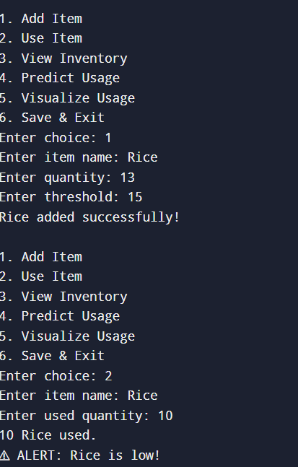

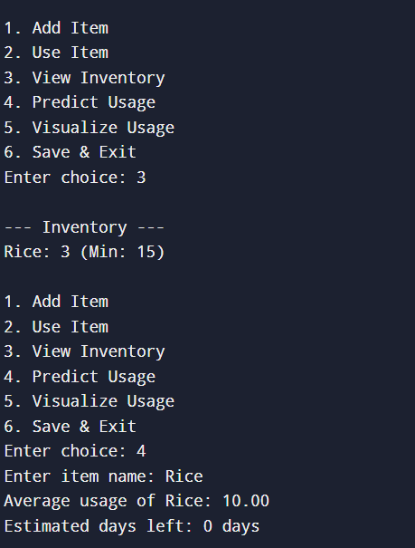

CONCLUSION

The Automated Household Inventory & Intelligent Consumption Analytics System (HI-CAS) is a useful Python-based application designed to manage and monitor household inventory effectively. The system helps users keep track of items such as groceries and daily essentials by allowing them to add, update, and view inventory records. It also records usage history and alerts users when the quantity of an item falls below a defined threshold.
The project demonstrates the practical application of Python programming concepts such as object-oriented programming, file handling, data structures, exception handling, and data visualization. By using libraries like NumPy, Pandas, and Matplotlib, the system is able to analyze consumption patterns and present usage trends through graphical visualization. Overall, the HI-CAS system provides a simple and efficient solution for household inventory management while helping users make better decisions about purchasing and consumption.

